Patrick Bondaruk

N00201161

DL836 Year 1

Date Submitted: 21/02/2021

DL836 – Creative COmputing  
Programming

Programming Continuous Assessment 2

Introduction

The animation that I have chosen to make is an animation of a bow and arrow shooting at the target. The reason why I chose this animation is because it was something creative and simple enough to create, and not that many people have done something like that before, so I decided to create it because it is something different and creative.

Design

I designed the animation by having a bow and an arrow loaded, while the target is moving up and down, and when the mouse button is pressed on the screen it would shoot out the arrow at the target. I designed the way so that when the mouse button is pressed it will move all the shapes that I have implemented to make an arrow, and they would all move to the right side by the x-axis. The bow will have a pulled string and when the mouse button is pressed the string will be straight.

Implementation

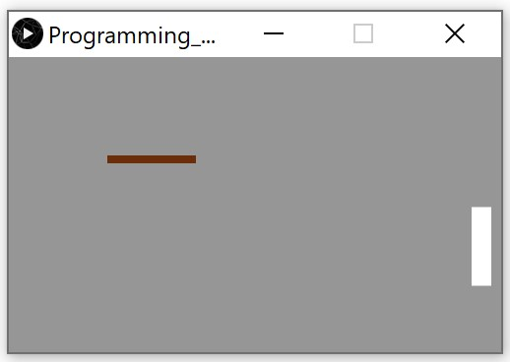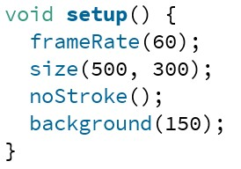I implemented the code by having the methods of void setup(), void draw(), and void mousePressed(). Then I had different variables like int, float, and boolean implemented outside of the methods. First I made a background with this code displayed at the images, which draws the background of a grey color. I then made a basic shape for the arrow and a target.

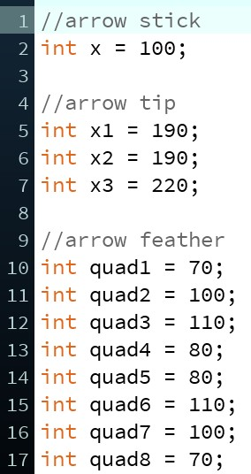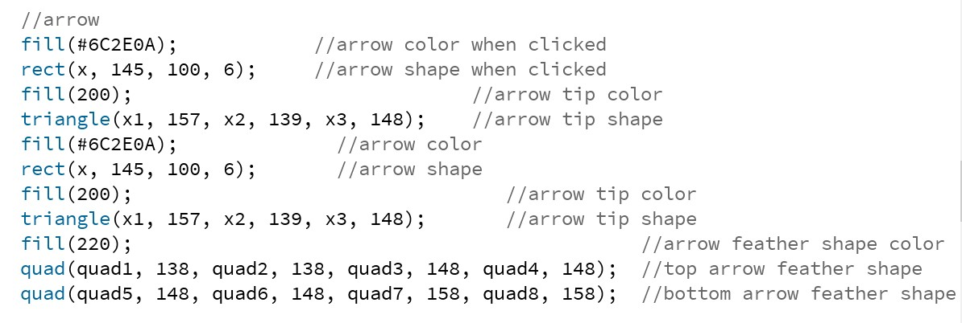I then implemented the code to create different shape to make an arrow.

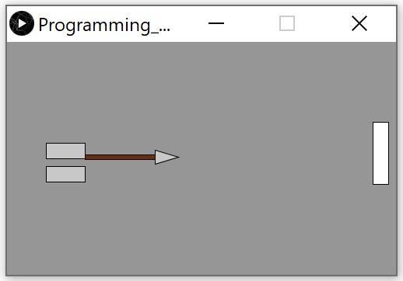This is how the arrow was displayed when it was in progress and when it was finished.

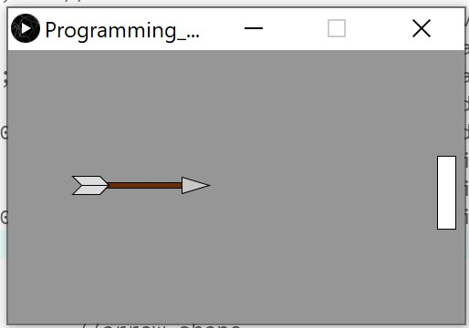

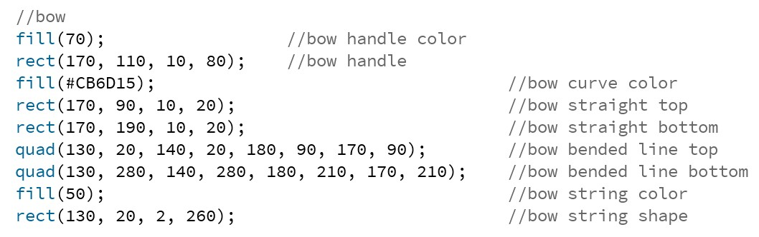I was then making a bow and implemented the codes the make different shapes to create a bow.

I used fill(); to fill in the colors for the shapes, and I used rect(); to create rectangles, and I used quad(); to make quadrangles.

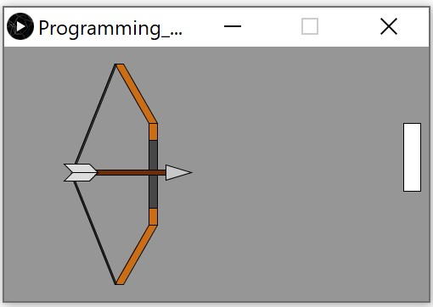This was the finished bow that I implemented.

I had the bow with the string pulled displayed by the image.

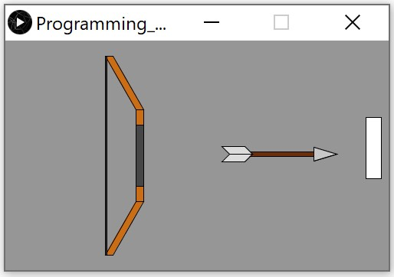Then when the mouse button was clicked on the screen, the bow would have a straight string when the arrow was shot displayed by the image.

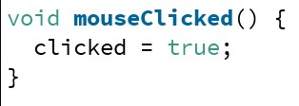

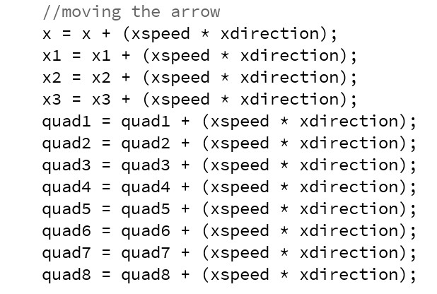I made the arrow move by having different variables of int and float implemented in the code for shapes. Then I commanded by when the mouse button was pressed the int and float variables would add by 1 every time for the x-axis, which would create a new image displaying over and over which makes the arrow look like it moves to the right side.

I implemented the variables for xspeed = 1; and xdirection = 1; so all the variables that have made they would be added up by xspeed multiplied by xdirection and added by the same variable.

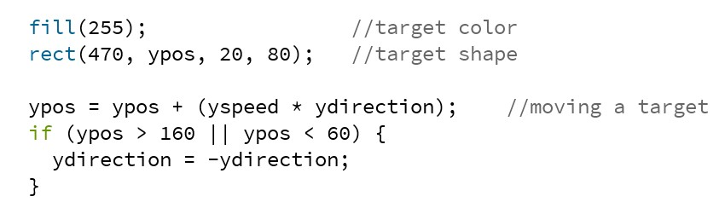I made the target to be moving up and down at the specific given location. I made the shape of a target and I commanded the y-axis which is for the up and down directions to be moving at specific points. So I told that if y position would be less than specific given number in that case it is 60, it would start going down. If y position will be more than specific given number in that case it is 160, it would start going up.

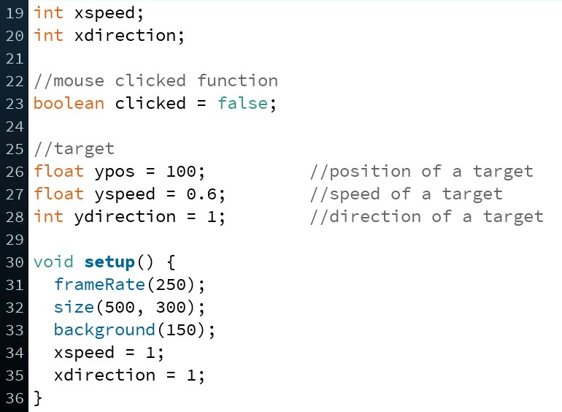I edited a bit of the setup on the process on my animation and decided to remove the noStroke(); function so the shapes would look more pronounced and sharper in the animation.

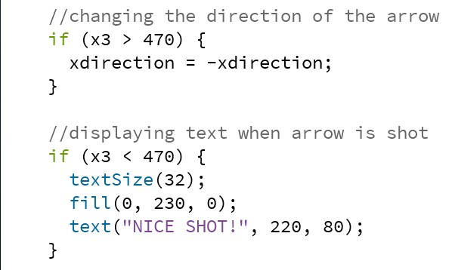After I made the moving arrow, I implemented an if statement, so that at the x-axis when it reaches at the specific x position, in that case it is 470, it will change an opposite direction and start moving left. It would look like as if the arrow bounced off the target.

After that I implemented text that displays on the screen when the mouse button is pressed. I made the text to be colored green, commanded what position to display it at, commanded what size to display and the text itself which would be written “NICE SHOT!” on the screen.

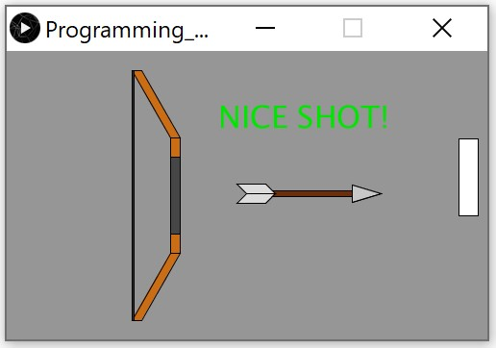This is my finished animation of a bow and arrow.

Result

Overall the work as I planned did work great. The things that didn’t really work for me the way I planned is that I wanted the arrow tip to collide with the target but I didn’t really fully know how collision works, but making it to bounce off worked just fine for me. The other thing is that I wanted the text to display after the arrow was hit, but I made the way the text would display after the mouse button was pressed which was just fine. In the result things worked out great.

Conclusion

What I learned after is the way to use methods and how to interact with the screen and how to move certain objects. What I would do differently is probably use more advanced functions and implement new codes that could be easier and better.

Reference

<https://processing.org/examples/bounce.html>

<https://processing.org/reference/mouseClicked_.html>

These are the reference links that helped me get the idea for implementing codes.